Steps to download HAR file:

- Open the browser and reproduce the issue.
- Click on F12 in browser where issue is reproduced after one refresh and click on network
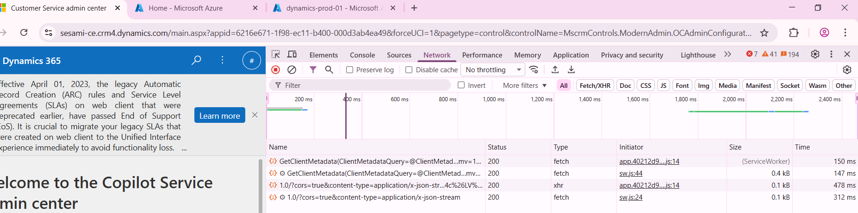
- All network logs will be collected and let the process of collecting network log stop completely
- Click on download as per the screenshot below and then save that file in local to hand over it to Microsoft ticket person.
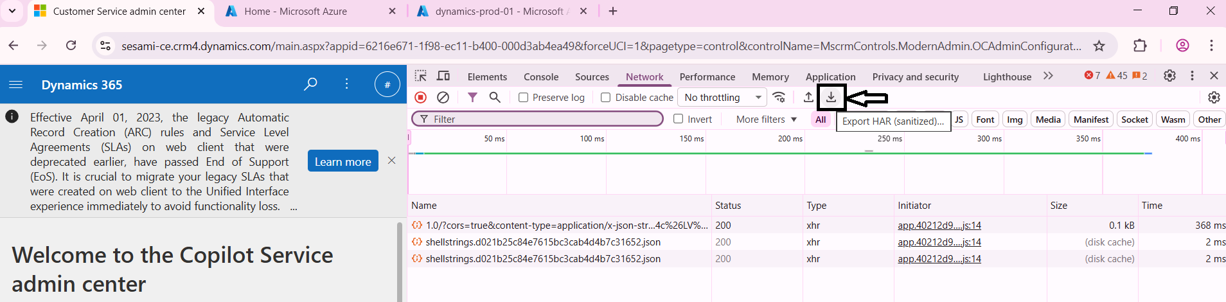
- Save the file as issue name and env name combination
